# Mini Project Report

On

# “EMPLOYEE MANAGEMENT SYSTEM”

**Submitted By**

|  |  |  |
| --- | --- | --- |
| Alamkhane Sakshi | [ T1903004204 | ] |
| Anarse Aditi | [ T1903004205 | ] |
| Aniket Prajapati | [ T1903004206 | ] |
| Eshan Bhakre | [ T1903004217 | ] |

**Under the guidance of**

Prof. Pradnya kothawade



DEPARTMENT OF COMPUTER ENGINEERING

**GENBA SOPANRAO MOZE COLLEGE OF ENGINEERING, BALEWADI, PUNE-411041**

SAVITRIBAI PHULE PUNE UNIVERSITY [Year:2024-2025]

## CERTIFICATE



This is to certify that the mini project report entitles

**“EMPLOYEE MANAGEMENT SYSTEM”**

Submitted by

|  |  |  |
| --- | --- | --- |
| Alamkhane Sakshi | [ T1903004204 | ] |
| Anarse Aditi | [ T1903004205 | ] |
| Aniket Prajapati | [ T1903004206 | ] |
| Eshan Bhakre | [ T1903004217 | ] |

has successfully completed his/her Project work on **“EMPLOYEE MANAGEMENT SYSTEM”** at Genba Sopanrao Moze College of Engineering, Balewadi, Pune in the partial fulfillment of Bachelor’s Degree in Computer Engineering.

( Prof . Pradnya kothawade ) (Prof. SaiSudha Dorabala) Guide Head,

Department of Computer Engineering Department of Computer Engineering

(Dr.Ratnaraj Kumar Jambi) Principal,

Genba Sopanrao Moze College of Engineering Pune – 45

Place : Pune Date :

## ACKNOWLEDGEMENT

With immense pleasure, we present the mini project report as part of the curriculum of the

T.E. Computer Engineering. We wish to thank all the people who gave us an unending support right from when the idea was conceived.

We express our sincere and profound thanks to **Prof. pradnya kothawade** our Mini Project Guide and our HOD **Prof. SaiSudha Dorabala** who always stood by us as the helping and guiding support and all those who have directly or indirectly guided and helped us in the preparation of the Mini Project.

**Name of Students**

**Alamkhane Sakshi**

**Anarse Aditi**

**Aniket Prajapati**

**Eshan Bhakre**

## LIST OF FIGUREs

|  |  |  |
| --- | --- | --- |
| **Figure No.** | **Figure Name** | **Page No.** |
| Fig 1.1 | Database information system | 9 |
| Fig 3.1 | System Architecture | 16 |
| Fig 3.3  Fig 4.1  Fig 4.2 | Flowchart of EMS  Database fetching  MySql connectivity | 19  24  24 |
|  |  |  |
|  |  |  |
|  |  |  |
|  |  |  |

## LIST OF ABBREVIATIONS

|  |  |  |
| --- | --- | --- |
| 1 | DBMS | Database Management system |
| 2 | EMS | Employee Management system |
| 3 | SQL | System Query Language |
|  |  |  |

**ABSTRACT**

This report includes a development presentation of an information system for managing the staff data within a small company or organization. The system as such as it has been developed is called Employee Management System. It consists of functionally related GUI (application program) and database.

The choice of the programming tools is individual and particular.

**Keywords**

Information system, Database system, DBMS, parent table, child table, table fields, primary key, foreign key, relationship, sql queries, objects, classes, controls.

## TABLE OF CONTENTS

|  |  |  |  |
| --- | --- | --- | --- |
| A |  | CERTIFICATE |  |
| B |  | ACKNOWLEDGMENT |
| C |  | LIST OF FIGURES |
| D |  | LIST OF ABBREVIATIONS |
| E |  | ABSTRACT |
| **1** |  | **INTRODUCTION** | **8** |
|  | 1.1 | Introduction | 8 |
|  | 1.3 | Background | 8 |
|  | 1.4 | Need | 9 |
| **2** |  | **PROBLEM DEFINITION AND SCOPE** | **10** |
|  | 2.1 | Problem Definition | 10 |
|  | 2.2 | Scope | 12 |
|  | 2.3 | Goal | 13 |
| **3** |  | **SYSTEM OVERVIEW** | **14** |
|  | 3.1 | System Architecture | 14 |
|  | 3.2  3.3 | Algorithm  Flowchart | 16  18 |
|  | 3.4 | Advantages | 19 |
|  | 3.5 | Disadvantages | 20 |
| **4** |  | **RESULT ANALYSIS** | **21** |
| **5** |  | **CONCLUSION** | **24** |
| 6 |  | **REFERENCES** | **25** |

## 1. INTRODUCTION

**1.1 Introduction**

This chapter gives a brief theoretical preview upon the database information systems and goes through the essence of the problem that should be resolved.

**1.2 Background**

Most of the contemporary Information systems are based on the Database technology as a collection of logically related data, and DBMS as a software system allowing the users to define, create, maintain and control access to the database.

The process of constructing such kind of systems is not so simple. It involves a mutual development of application program and database. The application program is actually the bridge between the users and the database, where the data is stored. Thus, the well-developed application program and database are very important for the

reliability, flexibility and functionality of the system.

The so defined systems differentiate to each other and their development comprises a great variety of tasks to be resolved and implemented.

The basic idea can be depicted on Figure 1.1 below:

 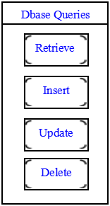

Database System

Database

DBMS

Application

program

**Figure 1.1 Database information systems - principle scheme**

Information system suggests a computer technology to be used in order to provide information to users in an organization (for instance), as for the purposes of data transformation into useful information; computer hardware and software are designed and used [2].

A particular case is the Human Resources Information System development. This kind of systems are responsible for storing data of the staff within an organization and generating reports upon request.

Such kind of system could be integrated with other Information systems or modules: Accounting Information System (AIS) – designed to transform financial data into information, or Management Information System (MIS) that provides decision-oriented information to managers, and so on …

“Organizations depend on Information Systems in order to stay competitive. Productivity, which is crucial to staying competitive, can be increased through better Information Systems.”

**1.3 Need**

An Employee Management System (EMS) is crucial for organizations of all sizes for several reasons:

1. Streamlined Processes : Automates HR tasks like onboarding, payroll, and performance evaluations, saving time and reducing errors.

2. Data Management : Centralizes employee information, making it easy to access and manage data like attendance, leave, and personal details.

3. Improved Communication : Facilitates communication between employees and management through features like internal messaging and announcements.

4. Performance Tracking : Helps in monitoring employee performance and productivity, enabling more informed decisions regarding promotions and training.

5. Compliance and Reporting : Assists in maintaining compliance with labor laws and regulations, and generates reports for audits and assessments.

6.Employee Engagement : Provides tools for feedback and surveys, promoting a culture of engagement and retention.

7. Time Management : Tracks work hours, attendance, and leave, aiding in better workforce planning and resource allocation.

8. Scalability : Supports the growth of the organization by easily accommodating new employees and changing structures.

Implementing an EMS can lead to more efficient operations, better employee satisfaction, and improved organizational performance.

**2. PROBLEM DEFINATION AND SCOPE**

**2.1 Problem Statement**

This report’s documentation goes through the whole process of both application program and database development. It also comprises the development tools have been utilized for these purposes.

**2.2 Problem Discussion**

This system should consist of an application program, on one hand, and a database (repository of data) on the other. The program should perform the basic operations upon the database as retrieving, inserting, updating and deleting data. Any additional functionality is a goal of a further module development.

It is a kind of strategy to start the development from designing and constructing the database, as this structure will determine the further structure of the application program.

The logical database model (tables, their content and the relationships between them) should respond to the given task and cover the basic requirements.

The Interface of the program should be user-friendly, and the program should be as easy for use as it is possible.

Both controls and forms should logically and functionally be related within the program and fully respond to the structure of the database.

Another problem is establishing the connections with the database, every time, when a query is needed to be performed upon it. Exception-handling should also be taken into an account during the system’s development due to eventual exceptions that may occur.

**2.3 Problem’s Solution**

This chapter involves some subsections that concern the basic scheme of resolving the given task and comprise both the methods and tools of its development as well.

**2.4 Method**

At the very commencement, I proceeded to a decision to carry out the development of my task into the following steps:

1. Exploring the available development environments and techniques.

2. Database Analyzing.

3. Database design and Implementation.

4. Program’s Structure Analyzing.

5. GUI (Graphical User Interface) constructing.

6. Bringing all the stuff together (controls data binding and functions implementation).

7. Tests.

Each one of these steps could be explained in some brief details as follows:

*1. Exploring the available development environments and techniques*

There is a lot of programming environments available to be used for such kind of elaborations. The point is to choose such an environment that we will be able to operate with in a convenient and easy way. This is more or less optional and individual process, that depends on the developer’s experience as well.

*2. Database Analyzing*

It concerns all of the demands, put upon the database content and its functionality. The database should be designed and implemented in a way that the user would expect it to be.

*3. Database design and Implementation*

This step is tightly related with the previous one as it is completely determined by the requirements, analyzed and discussed in step2.

*4. Program’s Structure Analyzing*

The application program as an interface between the users and the database should be an accurate “reflection” of the database on the screen; hence a well analyzed and defined structure is needed.

*5. GUI Constructing*

After analyzing the program’s structure and defining what it should consist of, a graphical representation of this stuff is needed in order to enable the user to interact with the data.

*6. Bringing all the stuff together*

The next step that should be taken is connecting the program with the database and performing the necessary functionality upon all of the controls.

*7. Tests*

To ensure that everything works properly and as it has been expected, test performance has to be done upon the system’s functionality.

**2.5 SCOPE:**

The scope of an Employee Management System typically includes:

1. **Employee Records Management**: Centralized storage of employee data, including personal information, job roles, and work history.
2. **Onboarding and Offboarding**: Streamlined processes for integrating new hires and managing exits, including documentation and training.
3. **Time and Attendance Tracking**: Tools for clocking in/out, tracking leave, and managing attendance records.
4. **Performance Evaluation**: Modules for setting goals, conducting appraisals, and collecting feedback from peers and supervisors.
5. **Payroll Management**: Automated payroll processing, including calculations for taxes, benefits, and deductions.
6. **Reporting and Analytics**: Generation of reports on various HR metrics, helping management make data-driven decisions.
7. **Compliance Management**: Features to ensure adherence to labor laws, including automated alerts for important compliance dates.
8. **Employee Self-Service Portal**: A platform for employees to access their information, submit leave requests, and view payslips.

**2.6 GOAL:**

**Goals of an EMS:**

1. **Enhance Efficiency**: Automate routine HR tasks to reduce administrative burden and increase productivity for HR staff and managers.
2. **Centralize Information**: Create a unified database for all employee records, making it easy to access, manage, and update information as needed.
3. **Improve Communication**: Foster better communication channels between employees and management to enhance engagement and collaboration.
4. **Streamline Onboarding/Offboarding**: Simplify the processes for hiring and exiting employees to ensure a smooth transition and integration into the organization.
5. **Optimize Performance Management**: Implement tools for setting objectives, tracking performance, and providing feedback to support employee development.
6. **Ensure Compliance**: Maintain adherence to labor laws and regulations by automating compliance tracking and reporting.
7. **Facilitate Data-Driven Decision Making**: Provide analytics and reporting features to help management make informed decisions based on employee performance and other key metrics.
8. **Enhance Employee Experience**: Offer self-service features for employees to manage their information, submit requests, and access resources, improving overall satisfaction and engagement.
9. **Support Scalability**: Design the system to easily accommodate growth, whether through new hires, expanded operations, or changing organizational structures.
10. **Cost Reduction**: Reduce operational costs by minimizing errors, decreasing manual processes, and improving resource allocation.

## 3. SYSTEM OVERVIEW:

## 3.1 System architecture:

### System Architecture of an Employee Management System (EMS)

An effective EMS architecture typically consists of several key components organized into a multi-tier structure. Here's a breakdown of the architecture:

#### 1. **Presentation Layer (User Interface)**

* **Web Interface**: Accessible via web browsers for HR personnel, managers, and employees.
* **Mobile Application**: Provides on-the-go access for employees and managers to view records, submit requests, and receive notifications.
* **Self-Service Portal**: A user-friendly interface where employees can update personal information, request leave, and view pay stubs.

#### 2. **Business Logic Layer (Application Layer)**

* **User Management**: Handles user authentication and authorization, ensuring secure access to the system.
* **Employee Management**: Manages employee records, onboarding, offboarding, and data updates.
* **Time and Attendance Management**: Tracks employee attendance, leave requests, and working hours.
* **Performance Management**: Facilitates goal setting, performance evaluations, and feedback collection.
* **Payroll Management**: Processes payroll calculations, tax deductions, and generates payslips.
* **Reporting and Analytics**: Generates reports for HR metrics, compliance tracking, and data analysis.

#### 3. **Data Layer (Database)**

* **Relational Database Management System (RDBMS)**: Stores all employee data, performance records, payroll information, and attendance logs. Examples include MySQL, PostgreSQL, or Oracle.
* **Data Security**: Implement security measures like encryption and access controls to protect sensitive employee information.

#### 4. **Integration Layer**

* **API Integration**: Allows integration with other systems such as accounting software, project management tools, or third-party applications.
* **Third-Party Services**: Integrates with external services for background checks, benefits management, or training platforms.

#### 5. **Infrastructure Layer**

* **Hosting**: The system can be hosted on-premises or in the cloud (e.g., AWS, Azure) to ensure scalability and accessibility.
* **Load Balancers**: Distributes traffic to ensure high availability and reliability.
* **Backup and Recovery**: Implements data backup solutions to protect against data loss.

#### 6. **Security Layer**

* **Authentication**: Multi-factor authentication to secure user access.
* **Authorization**: Role-based access control to limit data visibility based on user roles.
* **Audit Trails**: Tracks user actions within the system for accountability and complianc.

## Employee Management System | PPT

**Fig 3.1: system architecture**

**3.2 ALGORITHM:**

creating an employee management system (EMS) involves several key components. Here's a high-level algorithm broken down into essential functionalities:

### Employee Management System Algorithm

1. **Initialize System**
   * Create a database to store employee information (e.g., MySQL, MongoDB).
   * Define data structures for employee records (e.g., ID, name, position, department, salary, contact info).
2. **User Authentication**
   * Implement user login functionality for admins and employees.
   * Validate credentials against stored user data.
3. **Employee Operations**
   * **Add Employee**
     + Input employee details (name, position, department, salary, contact info).
     + Generate unique employee ID.
     + Save employee record in the database.
   * **View Employee**
     + Retrieve and display employee information based on ID or other search criteria (e.g., name, department).
   * **Update Employee**
     + Retrieve employee record using ID.
     + Allow modifications to selected fields (e.g., position, salary).
     + Save updates to the database.
   * **Delete Employee**
     + Retrieve employee record using ID.
     + Confirm deletion.
     + Remove employee record from the database.
4. **Reporting and Analytics**
   * Generate reports (e.g., total employees, employees by department, salary distribution).
   * Provide analytics (e.g., turnover rates, average salary).
5. **Department Management**
   * **Add Department**
     + Input department details (name, manager).
     + Save department in the database.
   * **View Department**
     + Retrieve and display department information.
   * **Update Department**
     + Retrieve department record.
     + Allow modifications and save updates.
   * **Delete Department**
     + Confirm deletion and remove department from the database.
6. **Search and Filter Functions**
   * Implement search functionality for employees and departments.
   * Enable filtering based on criteria (e.g., by salary range, department).
7. **User Role Management**
   * Define roles (admin, manager, employee).
   * Manage permissions based on roles (e.g., who can add/delete employees).
8. **Backup and Recovery**
   * Implement data backup procedures.
   * Create recovery options for restoring lost data.
9. **User Interface**
   * Design a user-friendly interface (web-based or desktop application).
   * Ensure intuitive navigation for all functionalities.
10. **Testing and Maintenance**
    * Conduct thorough testing of all features.
    * Plan for regular updates and maintenance.

**3.3 FLOWCHART:**

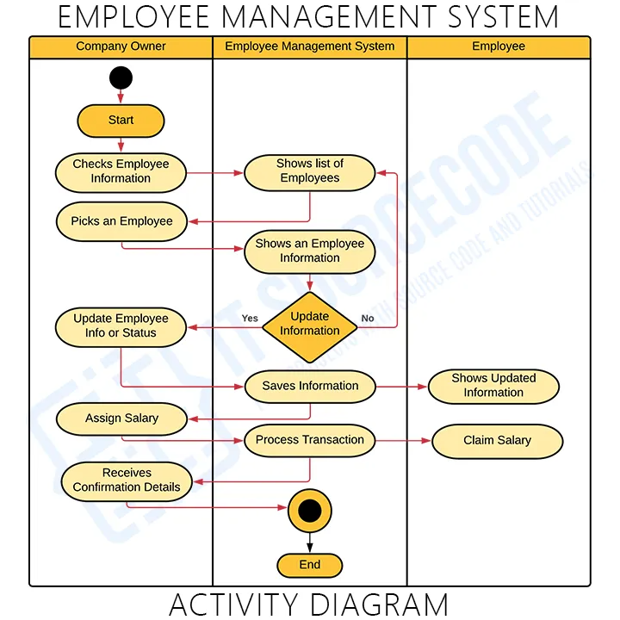

**Fig 3.3 : flowchart for EMS**

### **3.4 Advantages**

1. **Improved Efficiency**
   * Automates administrative tasks (e.g., payroll, attendance), reducing manual effort and errors.
2. **Centralized Information**
   * Stores all employee data in one place, making it easy to access and manage.
3. **Enhanced Communication**
   * Facilitates better communication between employees and management through integrated messaging or notifications.
4. **Data Analytics**
   * Provides insights through reporting tools, helping management make informed decisions based on employee performance and trends.
5. **Streamlined Recruitment**
   * Simplifies the hiring process by managing applications and tracking candidates effectively.
6. **Compliance and Reporting**
   * Helps ensure compliance with labor laws and regulations, making it easier to generate necessary reports.
7. **Improved Employee Experience**
   * Provides self-service options for employees to manage their own information (e.g., updating personal details, accessing pay stubs).
8. **Performance Management**
   * Enables tracking of employee performance and goal setting, facilitating professional development.

### 

**3.5 Disadvantages**

**1.Cost of Implementation**

* Initial setup and ongoing maintenance can be expensive, especially for small businesses.

1. **Complexity**
   * Can be overwhelming for some users, requiring training and adaptation to new systems.
2. **Data Security Risks**
   * Centralized data can be a target for cyberattacks; protecting sensitive employee information is crucial.
3. **Dependence on Technology**
   * Technical issues or system failures can disrupt operations and access to critical data.
4. **Resistance to Change**
   * Employees may be resistant to adopting new systems, leading to lower engagement during the transition.
5. **Customization Needs**
   * Off-the-shelf solutions may not meet all specific business requirements, leading to additional costs for customization.
6. **Maintenance Challenges**
   * Regular updates and troubleshooting are necessary to keep the system running smoothly.
7. **Integration Issues**
   * Difficulty integrating with existing systems or software can hinder functionality.

**4. RESULT ANALYSIS**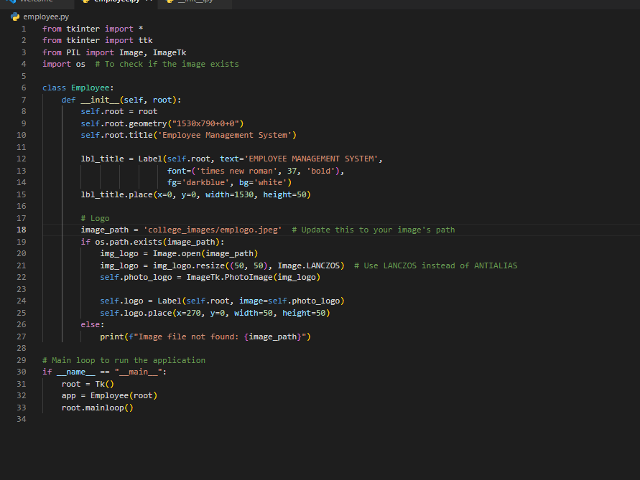

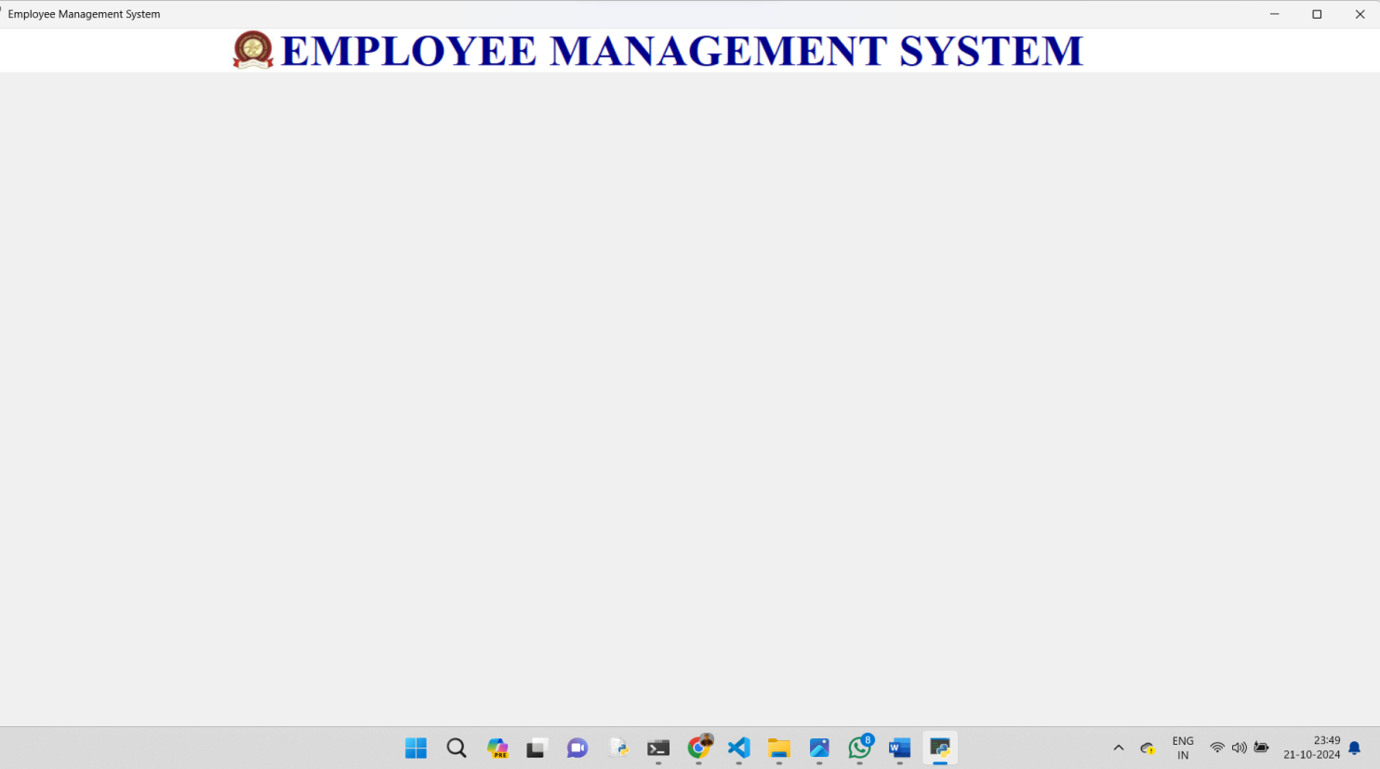

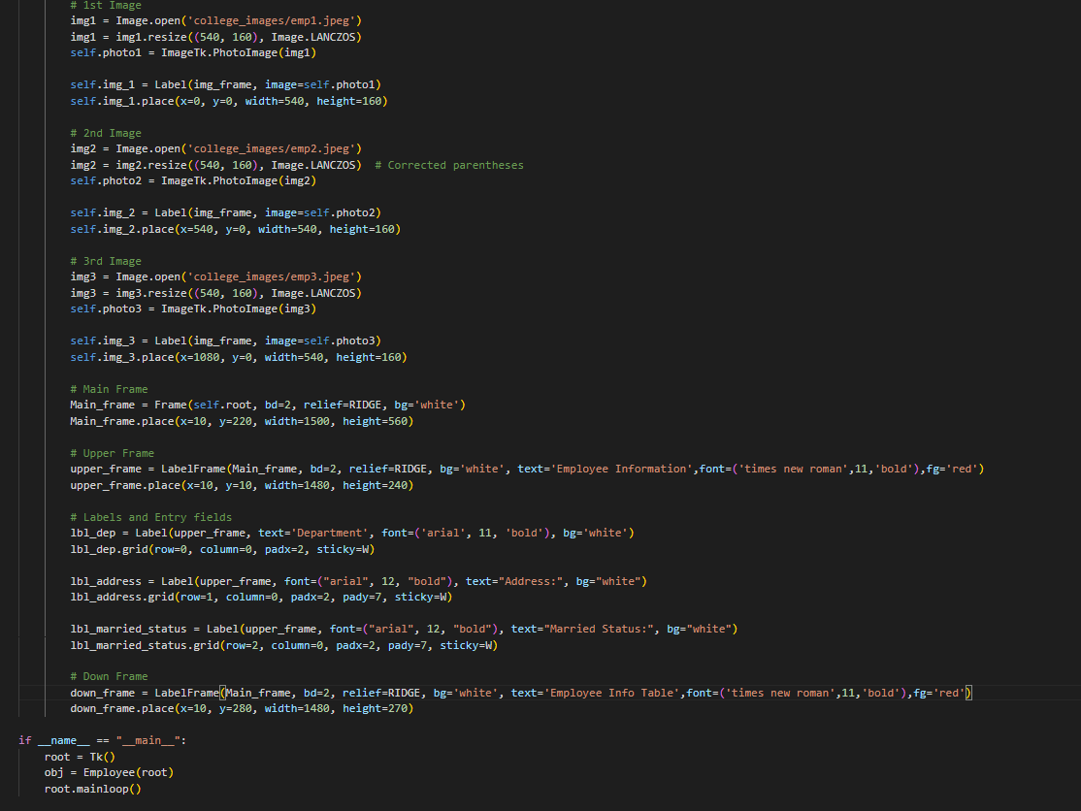

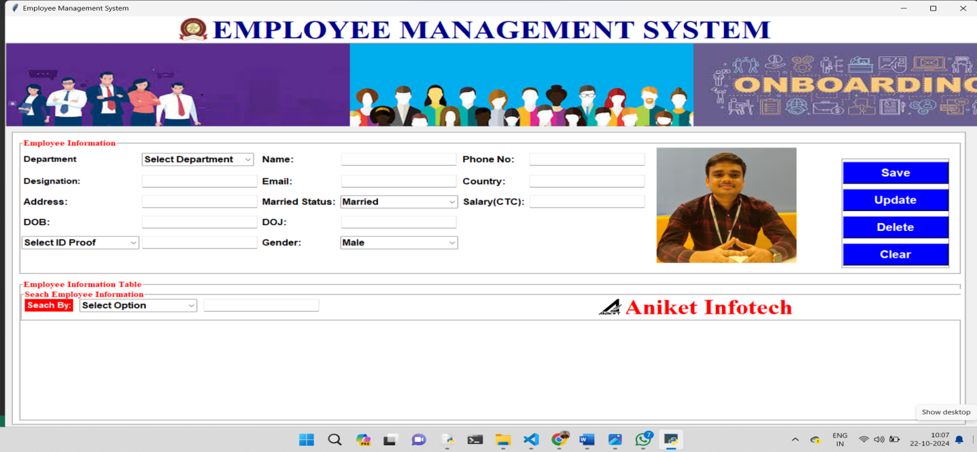

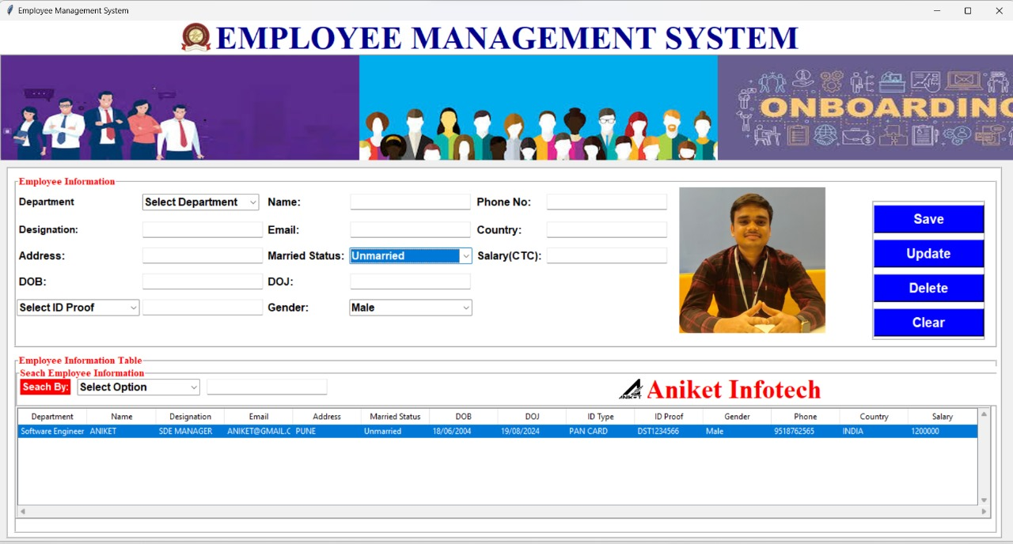

**Fig 4.1 : Database Fetching Image**

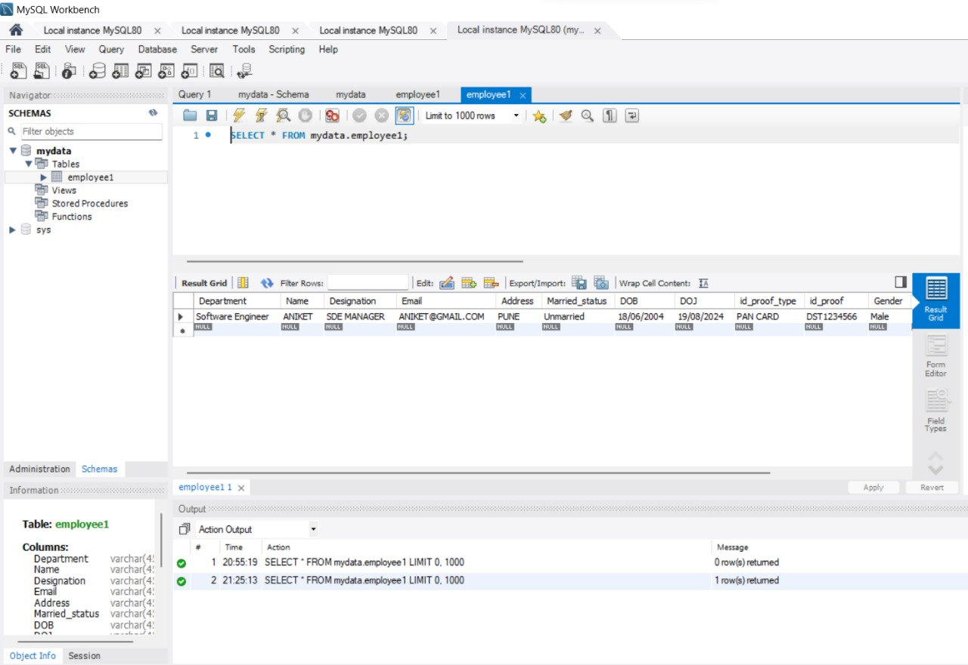

**Fig 4.2 : MySql connectivity**

**5. CONCLUSION:**

An Employee Management System (EMS) is a vital tool for organizations aiming to streamline human resource processes and enhance overall efficiency. By automating tasks such as employee data management, payroll processing, and performance tracking, an EMS reduces administrative burdens and minimizes errors.

The implementation of an EMS brings several key benefits, including centralized data storage, improved communication, and the ability to generate insightful reports. These advantages empower management to make informed decisions regarding workforce planning, employee development, and resource allocation.

However, organizations must also be mindful of the challenges associated with EMS implementation, such as cost, complexity, and data security concerns. It is crucial to invest in proper training, ongoing support, and robust security measures to maximize the system's effectiveness and safeguard sensitive employee information.

Through effective analysis of EMS data using graphical representations like flowcharts and various types of charts, organizations can gain deeper insights into employee demographics, performance metrics, turnover rates, and satisfaction levels. This analysis enables proactive management strategies that foster a positive work environment and contribute to employee retention and engagement.

Ultimately, a well-implemented Employee Management System not only enhances operational efficiency but also supports the organization's long-term goals by building a motivated and productive workforce.

**REFRENCES:**

### **Tutorials and Courses**

**1.Coursera and Udemy**

* + Online courses on HR management and employee systems, which can provide practical insights and skills. Look for courses related to HR technology.

**Articles:**

· **"Employee Management Systems: A Comprehensive Overview"** - This article discusses the various components of employee management systems, including recruitment, performance evaluation, and employee engagement.

· **"The Role of Technology in Employee Management"** - This piece examines how technological advancements, like HR software and mobile applications, are transforming traditional employee management practices.

· **"Best Practices for Implementing an Employee Management System"** - This article offers practical advice for organizations looking to implement or upgrade their employee management systems, covering planning, execution, and evaluation.

Top of Form